EMMANUEL BOADI ATTAFUAH
REG NO : SM/SMS/09/0053
group 13

THE WATER EQUIVALENT OF CALORIMETER
EXP 8

13/10/2009

TITLE :EXPERIMENT ON THE WATER EQUIVALENT OF A CALORIMETER.
AIM: To determine the water equivalent of a calorimeter.
APPARATUS
Copper calorimeter with outer jacket, stirrer made from bare copper wire, thermometer, beaker and a stove.

DIAGRAM
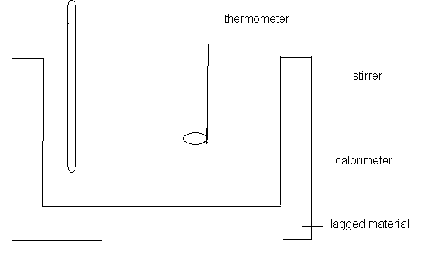

THEORY
Heat is a form of energy that a body possesses when heat flows into it. Heat energy can be measured in the units joule (J). Substances differ markedly in temperature rise caused by the absorption of a given amount of energy. In general, when the temperature of a body changes by an amount Δt, the heat ΔQ that flows in or out of it is given by ΔQ = mcΔt where m is its mass and c is specific heat. The product mc is called the THERMAL CAPACITY or WATER EQUIVALENT of the body. Therefore, water equivalent of calorimeter is the measure of the quantity of heat required to raise the temperature of the calorimeter or make it one degree warmer. Water Equivalence is not the same for substances made from the same material because it depends on the mass of the material use for the substance. Therefore, water equivalence can also be defined as the number of grams of water, which require the same amount of heat to cause a given change in temperature that is required to reproduce an equal change in the temperature of the inner vessel with the stirrer and thermometer.
Heat gained by calorimeter and cold water= Heat lost by warm water
M_{I}C_{W} ($θ$₃-$θ$₁) + M_{C}C_{C} ($θ$₃-$θ$₁) = M_{F}C_{W} ($θ$₂-$θ$₃)
Where M_{I} = Mass of cold water
M_{C} = Mass of calorimeter
M_{F} = Mass of warm water
C_{W} = Specific heat capacity of water
C_{C} = Specific heat capacity of calorimeter
.
M_{I}C_{W} ($θ$₃-$θ$₁) + M_{C}C_{C} ($θ$₃-$θ$₁) = M_{F}C_{W} ($θ$₂-$θ$₃)
But C_{C} = C_{W}, since the water equivalent is the mass of water that has the specific capacity of the calorimeter.
C_{w} (M_{I}+M_{C}) ($θ$₃-$θ$₁) = M_{F}C_{W} ($θ$₂-$θ$₃)
(M_{I}+M_{C})$( θ$₃-$θ$₁) = M_{F} ($θ$₂-$θ$₃)
But M_{I} = M₁ - M₀, M_{F} = M₂ - M₁ and M_{c} = w
(M₁-M₀+w) ($θ$₃-$θ$₁) = (M₂-M₁) ($θ$₂-$θ$₃)
METHOD
The calorimeter and stirrer were initially weighed together. Ice-cold water was then poured into the calorimeter until it was about one-third full, weighed, and placed in its outer jacket and left to stand until its temperature was about 5℃ below the room temperature. Meanwhile, some water was heated up in a beaker until its temperature was about 15℃ above the room temperature. The stove was removed from underneath the beaker and after stirring both the warm water and the water in the calorimeter; their temperatures were taken separately and as accurately as possible. Some of the warm water was then poured from the beaker into the calorimeter until it was about two-thirds full. It was stirred and the highest temperature reached by the mixture about 5℃ above room temperature was recorded. The calorimeter with its contents and the stirrer was weighed again.

TABLE OF RESULTS
Reading | Symbols | Values
Weight Calorimeter and Stirrer | M_{O} | 54.9g
Weight of Calorimeter + Stirrer + Cold water | M₁ | 93.8g
Weight of Calorimeter + Stirrer +Mixture M₂ | M₂ | 135.2g
Initial temperature of coldwater | θ₁ | 24℃
Initial temperature of warm water | θ₂ | 44℃
Final temperature of mixture | θ₃ | 34℃
Room temperature = 29℃

CALCULATION
Heat gained by calorimeter and cold water = Heat lost by warm water
(M₁-M₀+w) ($θ$₃-$θ$₁) = (M₂-M₁) ($θ$₂-$θ$₃$)$
W= $\frac{\left(M^{2}-M^{1}\right)(θ2-θ3)}{(θ3-θ1)}$ - $(M1-M0)$
W= $\frac{\left(135.2-93.8\right)g \left(44-34\right)℃ }{(34-24)℃}$ -(93.8 – 54.9)g
W=41.4g – 38.9 g = 2.5g

DISCUSSION
From the experiment, the water equivalent obtained for the calorimeter was found to be 2.5g. In theory the water equivalent is 5.49g. The actual value was not obtained due to some errors during the experiment such as some impurities in the water, and the inconsistency in the room temperature and some personal errors such as overheating the water in the beaker which all affected the results.

SOURCES OF ERROR
- Error may be to the use of impure water.
- Error may be due to heat transfer from hand to the compartment while holding the stirrer to stir.
- Error from slight spillage during the stirring process.
PRECAUTION
- It was ensured that the mixture of warm water and the cold water in the calorimeter was well stirred to ensure uniform distribution of heat before the temperature was read.
- It was ensured that the calorimeter was lagged (put in the outer jacket) to minimize the temperature loss in the water.
- It was ensured that all temperatures were read accurately to obtain accurate results.
CONCLUSION
From the experiment, the water equivalent of the calorimeter is 2.5g.
REFERENCES
RAYMOND A. SERWAY, JERRY S. FAUGHN (COLLEGE PHYSICS), 6TH EDITION 2003. HARCOURT COLLEGE PUBLISHER.
YOUNG FREEDMAN, (UNIVERSITY PHYSICS) 9TH SDITION, WESLEY PUBLISHING COMPANY,.
NELKON MICHAEL, PARKER PHILIP, (ADVANCED LEVEL PHYSICS) 7TH EDITION,

